|  |  |  |  |  |  |
| --- | --- | --- | --- | --- | --- |
| Date | 24-Nov-22 | | | Tester Name | Mohammad Yusuf |
| Environment | Select Environment | | | Login used |  |
| Operating System | Select OS | Version: | Update: | | |
| Software Used | Firefox | Version: | Update: | | |
| Select Software | Version: | Update: | | |
| Release version |  | | | | |
| Title | M33.06 Enter Non Resident Tax Instruction | | | | |
| Test Type | Regression | | | | |
| Test Scenario | Enter Non-Resident Tax Instruction | | | | |
|  |  | | | | |
| Expected Results |  | | | | |
| Pass/Fail | Select | | | JIRA# | N/A |

Describe your steps with screenshots:

Person profile

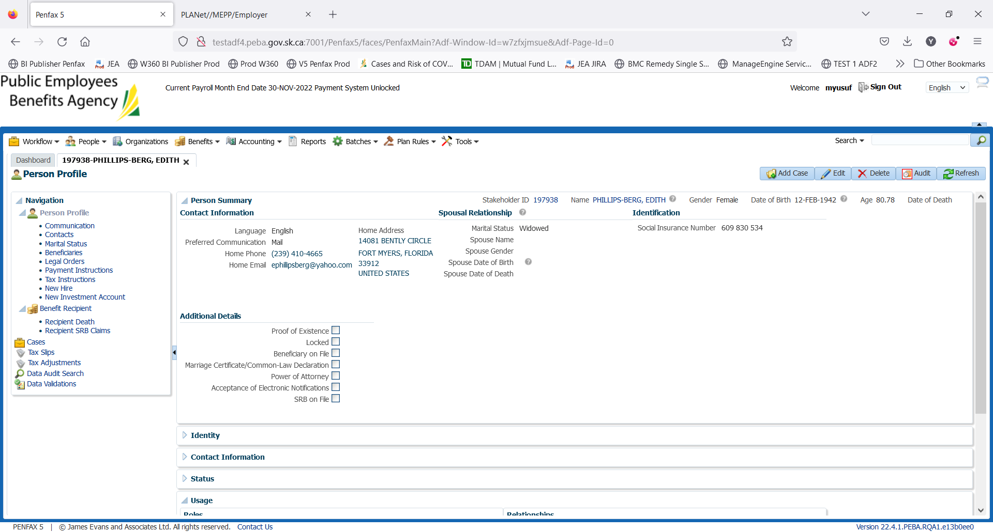

Add TAX Instructions for the nonresident year 2022

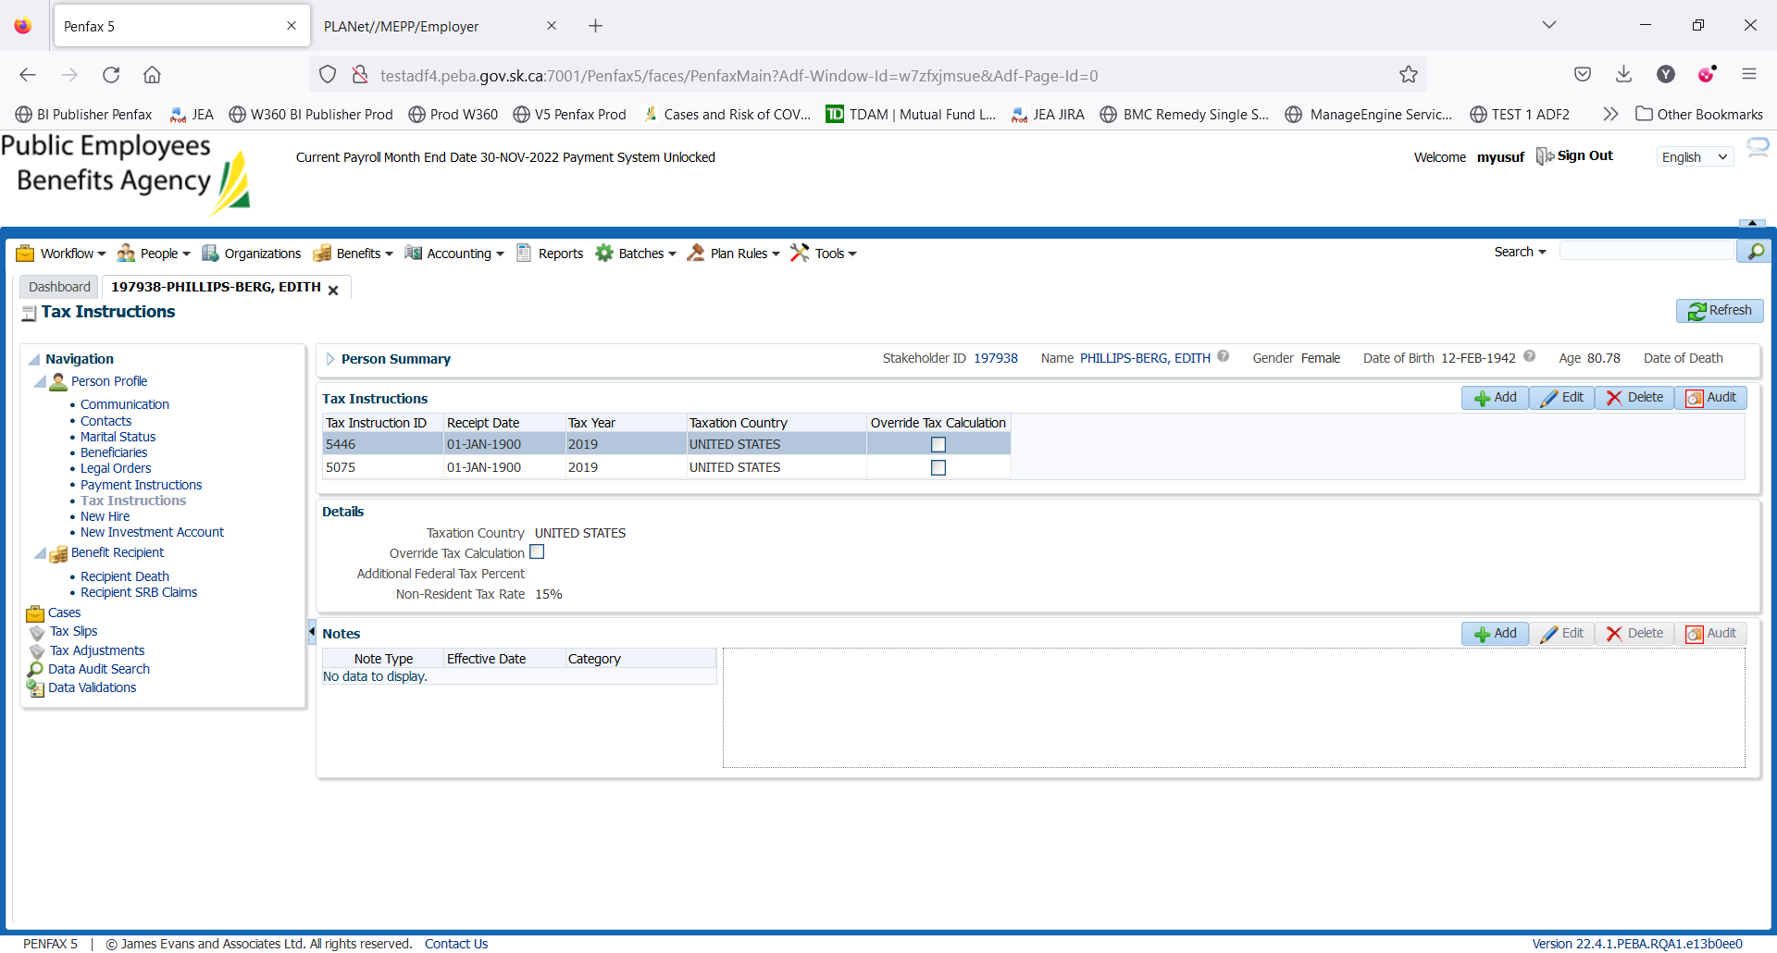

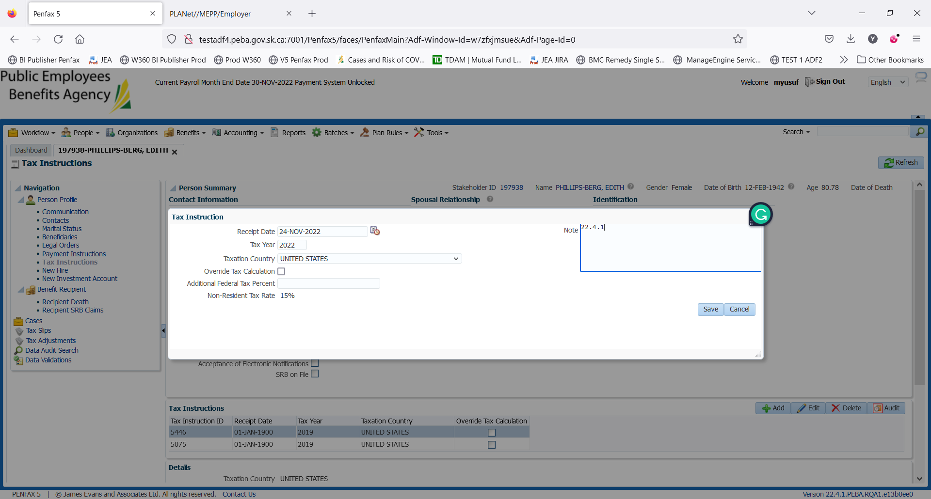

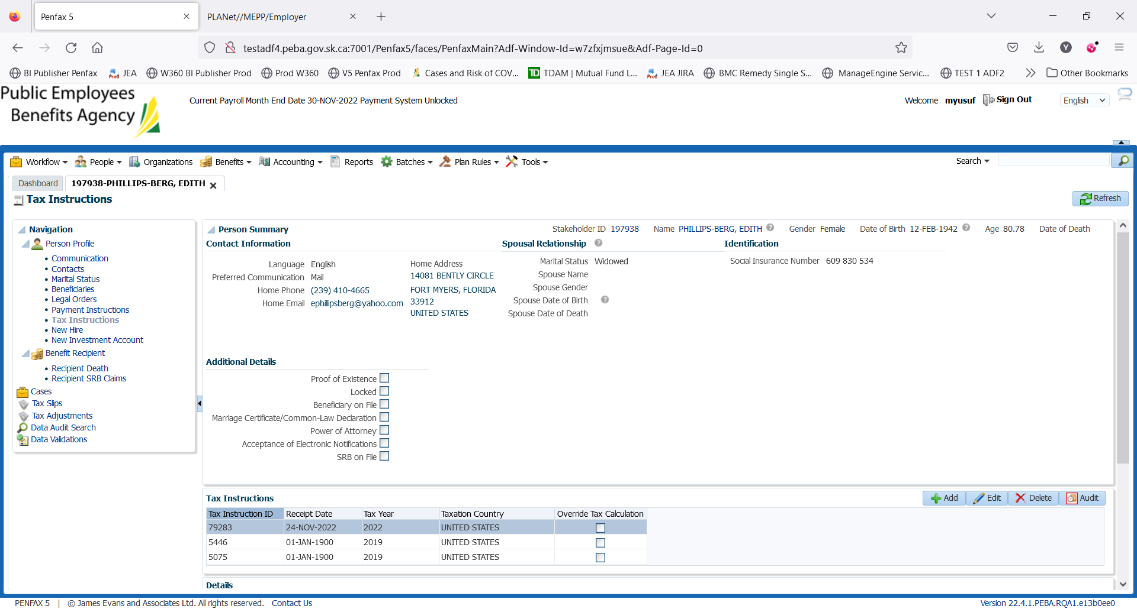

Save it

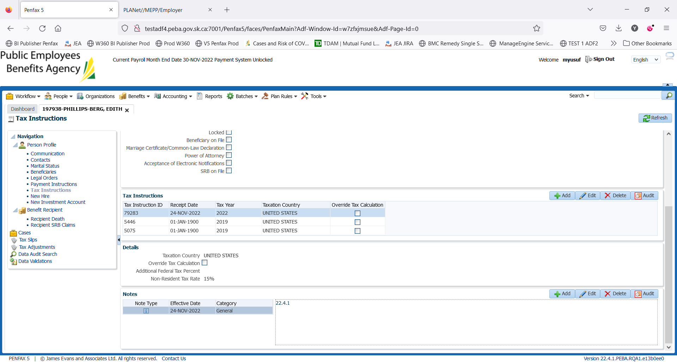

Link on BR and use start date November 22 to process may payment

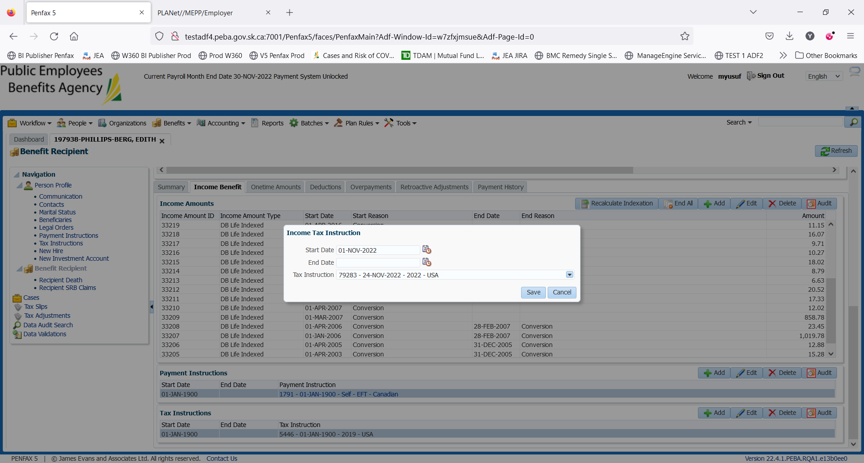

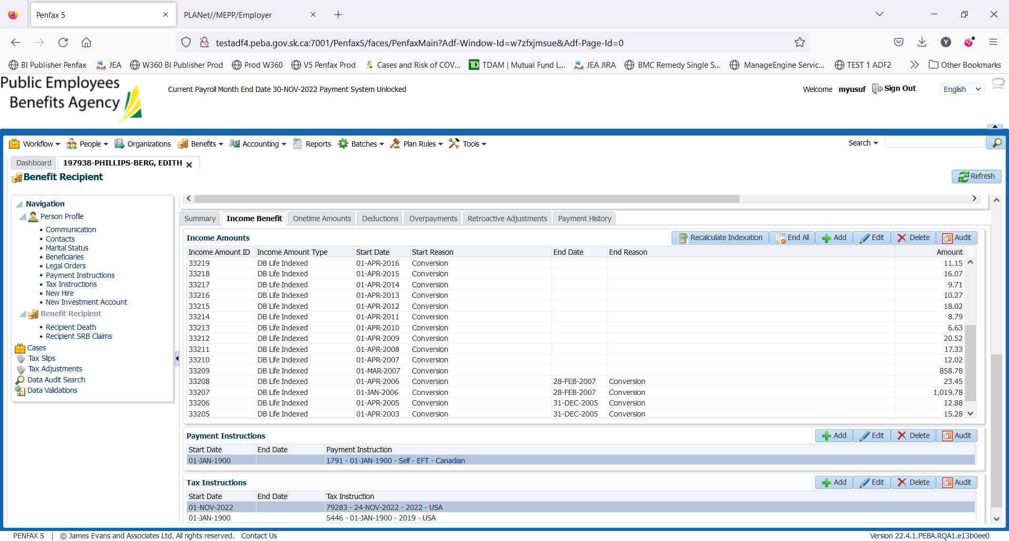

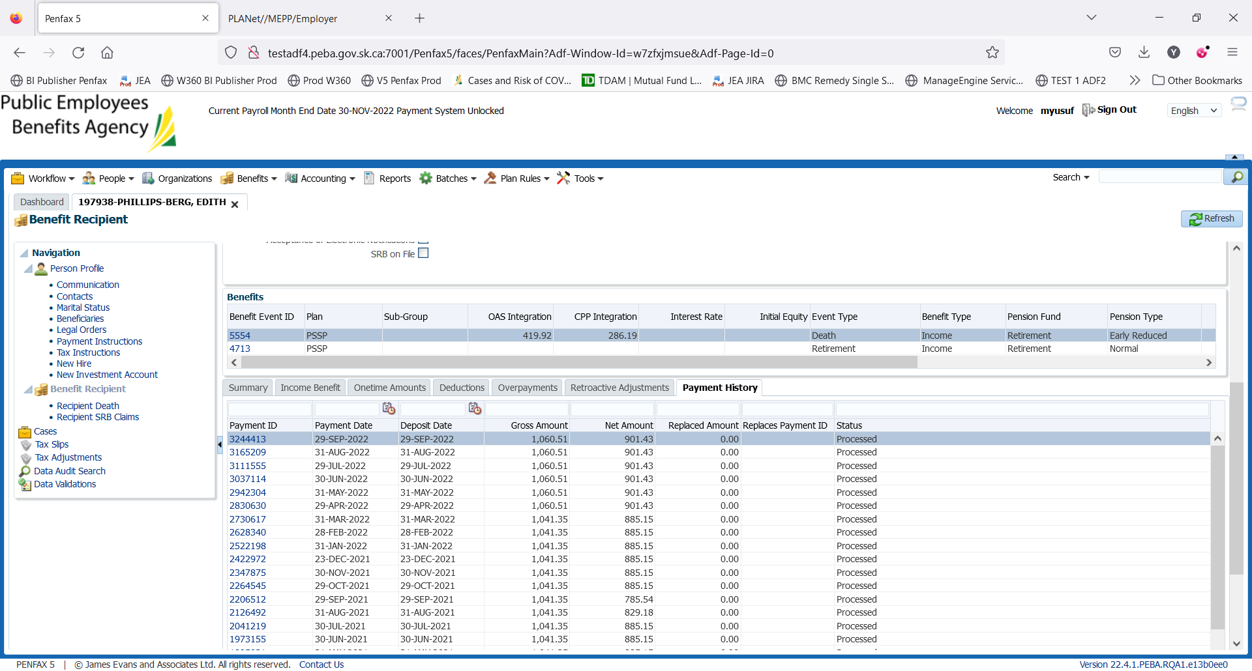

After the payment batch is run for Oct and Nov 2022. We should be able to validate the results. As other testers will be adding the payments as per their requirements

Will verify the next payment, if the application is not refreshed:

Sample Validation Screenshots below are from prior regression testing:

